Project Design Phase-II
Data Flow Diagram & User Stories

Date | 14 July 2026
Team ID
Project Name | Online Complaint Registration
Maximum Marks | 4 Marks

Data Flow Diagrams:
A Data Flow Diagram (DFD) is a graphical representation that illustrates how data moves through the Online Complaint Registration System. It shows the flow of information between users, processes, databases, and administrators. The DFD helps in understanding how the system collects, processes, stores, and retrieves data while ensuring efficient complaint management.
In the Online Complaint Registration System, the primary entities are User, Administrator, and Department Officer. The user registers and logs into the system, submits complaints, uploads supporting documents or images, and tracks the complaint status. The administrator manages users, departments, and complaint assignments, while the department officer updates the complaint status after resolving the issue.
The system consists of several major processes, including User Authentication, Complaint Registration, Complaint Management, Complaint Assignment, Status Update, and Notification Service. All user and complaint information is stored securely in the User Database and Complaint Database. Whenever a complaint is updated, the system sends notifications to the user through email or SMS.

Example: DFD Level 0 (Industry Standard)

Example: (Simplified)
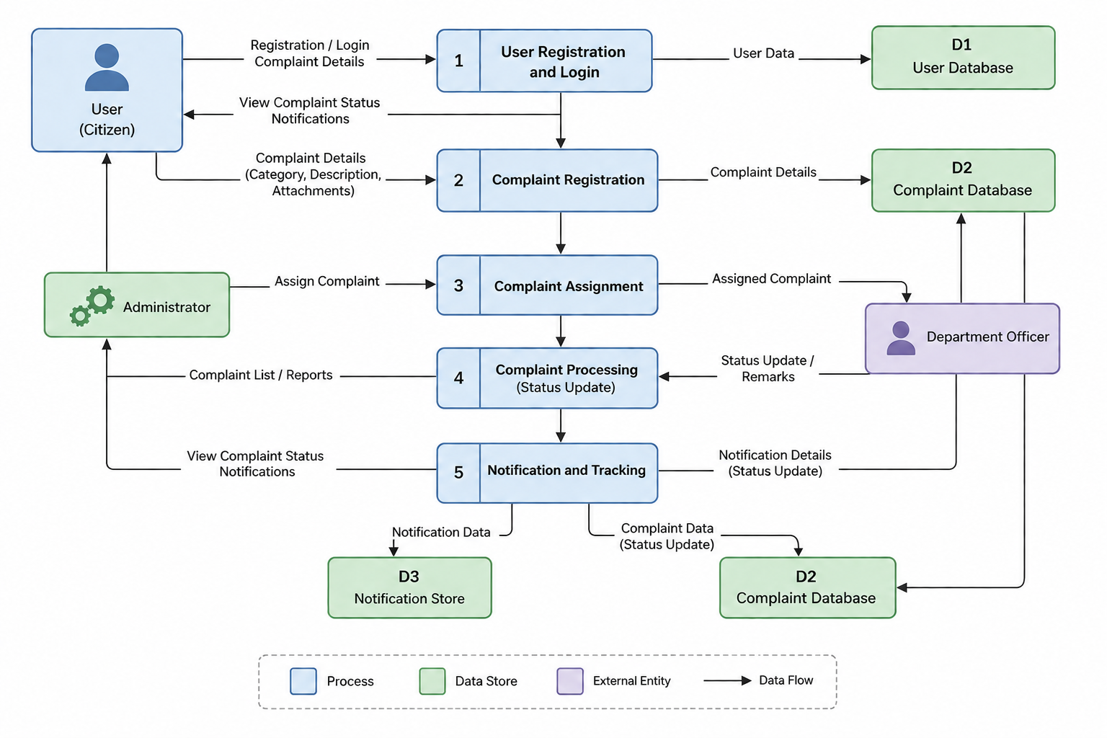
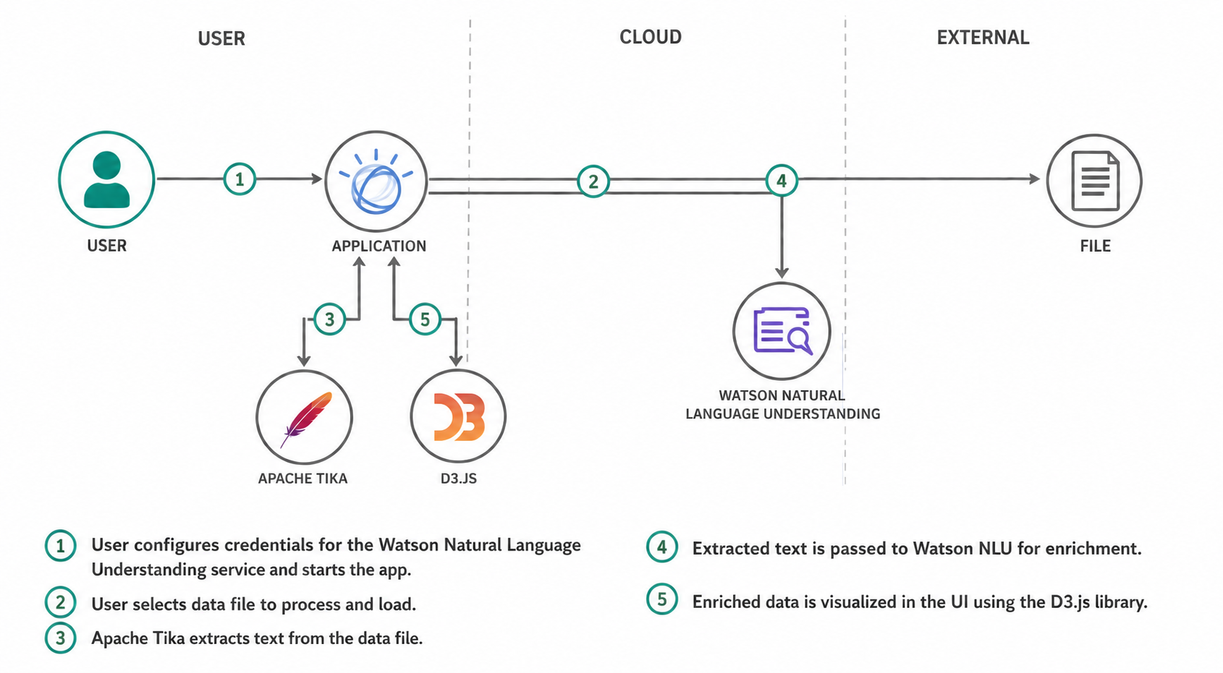

User Stories
Use the below template to list all the user stories for the product.
User Type | Functional Requirement (Epic) | User Story Number | User Story / Task | Acceptance Criteria | Priority | Release
Customer (Web User) | Registration | USN-1 | As a user, I can register by entering my name, email, mobile number, and password. | User account is created successfully and redirected to login. | High | Sprint-1
 | Email Verification | USN-2 | As a user, I receive a confirmation email after registration. | User can verify the account using the email link. | High | Sprint-1
 | Login | USN-3 | As a user, I can log in using my email and password. | User is successfully logged in and can access the dashboard. | High | Sprint-1
 | Dashboard | USN-4 | As a user, I can view my dashboard containing my complaint details. | Dashboard displays all submitted complaints and their statuses. | High | Sprint-1
 | Lodge Complaint | USN-5 | As a user, I can submit a complaint by selecting a department, entering complaint details, and uploading an image. | Complaint is successfully stored in the database with a unique complaint ID. | High | Sprint-1
 | Track Complaint | USN-6 | As a user, I can track the current status of my complaint. | Complaint status (Pending/In Progress/Resolved) is displayed correctly. | High | Sprint-2
 | Complaint History | USN-7 | As a user, I can view all my previously submitted complaints. | Complaint history is displayed successfully. | Medium | Sprint-2
 | Notifications | USN-8 | As a user, I receive email notifications whenever my complaint status changes. | Notification email is delivered successfully. | Medium | Sprint-2
Department Officer | View Assigned Complaints | USN-9 | As a department officer, I can view complaints assigned to my department. | Assigned complaints are displayed successfully. | High | Sprint-2
 | Update Complaint Status | USN-10 | As a department officer, I can update complaint status and add remarks. | Complaint status and remarks are saved successfully. | High | Sprint-2
Administrator | Manage Users | USN-11 | As an administrator, I can view and manage all registered users. | User details are displayed and managed successfully. | High | Sprint-1
 | View Complaints | USN-12 | As an administrator, I can view all complaints submitted by users. | All complaints are displayed successfully. | High | Sprint-1
 | Assign Complaints | USN-13 | As an administrator, I can assign complaints to the appropriate department officer. | Complaint is assigned successfully. | High | Sprint-2
 | Manage Departments | USN-14 | As an administrator, I can add, edit, and delete complaint departments. | Department information is updated successfully. | Medium | Sprint-2
 | Generate Reports | USN-15 | As an administrator, I can generate reports on complaint statistics and resolutions. | Complaint reports are generated successfully. | Low | Sprint-3

